1.1 Administration of the server is always right.
1.2. Any provocative activities aimed at suppressing the development of the resource - is prohibited.
1.3. The rules of server can be added / modified / removed at any time
1.4. Ignorance of the rules does not exempt from punishment.
1.5 Giving false evidence is punishable.
1.6 При нарушении правил, игроком принадлежащего к группе / отряду / гильдии - наказание понесут все участники! Следите за легитимностью действий своих напарников!
1.6. In case of violation the rules, a player belonging to the group / squad / guild - a punishment will bear all the participants! Follow the legitimacy of your teammates!
1.7 If the administration of server is not right, see paragraph 1.1; =)

PROHIBITED on server:
2.0 Using other Steam accounts for violation of the rules - ban of all accounts.
2.1. Incitement of ethnic hatred, religious and racial discrimination.
2.2. Insults and profanity against the other players.
2.3. The use of any cheats / bugs / dupes / scripts / shortcomings of the game, "black holes", "pitfalls" as well as ditches that provide an advantage over other players.
2.4. Using an objects that have the ability to change the height (timber, carts, etc.) to overcome obstacles (fences, houses, etc.), Established not by the laws of physics (eg, wooden boxes, set one by one, with a gap). Overcoming the walls in a jump on a horse with a "springboard" is prohibited. Palisade can be overcome with the help of a partner.
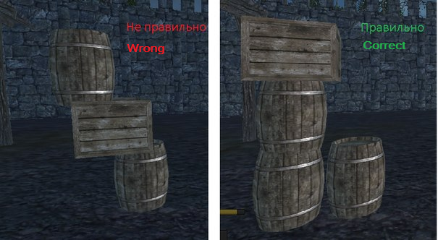

2.4.1 Use the "explosive charges" may only be used to undermine the gates and walls.
2.4.2 Firebolt is allowed to destroy the only wooden buildings. (the stone doesn't burn)
2.5. Relog or stuck, have been used to overcome obstacles.
2.6. Overly aggressive behavior of the player, aimed at the suppression of the server. Due to the high variability of the situation makes the final decision by the administrator.
2.7. The purposeful destruction of other people's outbuildings, are not carrying defensive value, during the siege strictly prohibited. Penalty: full reimbursement of the cost of construction of necessary resources.
- Houses [House with registration] is not an outbuilding, they can be destructive to the capture of the fortress [element siege]
- It is strictly forbidden to attack and DESTROY the monument of opponent. PENALTY: full reimbursement of all stolen loot and just inflicted during a raid damage the community (including the cost of the monument)
During a relapse - BAN.
2.8. Systematic out of the game in the opponent's territory.
2.9. Murder during revival (spawn on the beach, in / on buildings owner, on condition that the owner: no loot / does not conduct aggressive actions / provocation / doesn't use skills / remains in the cell spawn / not trying to loot anything).
2.10. Use trees as fence or instead of wall.
2.11. Any attacks, spy activities, etc. * on any territory that occupied by other players, without full set of armor (except default clothes) are prohibited. Exception - the defense of own territory.
Long stay close to territory that occupied by other players considered like SPYING !!!
Note: If during the siege you have been killed by defenders. Before returning to the battlefield, you have to wear the full set of armor.
Note for "VERY SMART GUYS": return to battlefield in naked condition without any cloth or armor set is prohibited!
2.12. Any attack, spying, etc. * at other people's settlements by characters who have at least 400 skill points on the combat or craft pages. Exception - the defense of own territory.
2.13. Shift the objects that possible to move through the open windows of buildings and loot these objects are allowed!
2.14. Blocking or occupying the clay spawn points, animals and other important minerals.
2.15 The castle, fort, settlement or consolidation must have at least 1 normal entrance, not depending where it placed on a hill or valley. Regardless of whether it is protected or no.
2.16 The griefing actions are prohobited (BAN)! Garbage on felling: stumps and spreading of timber in terrible quantity the punishment is reset of skills for wood feller / lumberjack to "0" points for all players belong to violator's guild.
3.0. Other situations by decision of the administration that are not described in this paragraph, since all the situations can't be foreseen.

The Player can get the warning for:
- Violation of regulations 1.2, 2.1 - 3.0

The Player can be kicked from server for:
- Violation of regulations 1.2, 2.1, 2.2, 3.0

The Player can be wiped (full or partly reset of all skills):
- Violation of regulations 2.6- 2.9, 3.0

The Player can be banned on server for:
- Violation of regulations 1.2, 2.3, 3.0 (forever)
- Violation of regulations 2.1, 2.2, 2.12 - 2.14, 3.0 ban 1 day, 3 days (unban after the explanation on forum) and final ban the permanent.
- Violation of regulations 2.4 - 2.10 ban 3 days (unban after the explanation on forum) and final ban the permanent.

Spying* - staying on territory of opponent without making of damage to buildings or other players who lives there.

